**Procedure**

Start the Windows **Command Prompt** and type in the following commands to see what they do.

***Part 1:***

***Exercise #1***: Command: CD

1. **Type in: CD /?**

Read the help pages for the **cd** command. What is the purpose/output of the **cd** command?

Change directory (cd)

Change directory to the root (cd/)

***Exercise #2***: command cd..

Type the following command and press **Enter**

1. **Type in: cd.. /?**

Read the help pages for the **cd..** Command. What is the purpose/output of **cd..** Command?

Move up one directory (cd..)

***Exercise #3***: command ***dir***

Type the following command and press **Enter**

1. **Type in: dir /?**

Read the help pages for the **dir** command. What is the purpose/output of **dir** command?

List all files and directories in the current working directory.

***Exercise #4***: **whoami**

Type the following command and press **Enter**

1. **Type in: whoami /?**

Read the help pages for the **whoami** command. What is the purpose/output of **whoami** command?

Display the user you are currently logged in and using

***Exercise #5***: **cls**

Type the following command and press **Enter**

**Type in: cls /?**

Read the help pages for the **cls** command. What is the purpose/output of **cls** command?

Clear screen

***Exercise #6***: **echo**

Type the following command and press **Enter**

**Type in: echo /?**

Read the help pages for the **echo** command. What is the purpose/output of the **echo** command?

Outputs the strings that are passed to it as arguments

***Exercise #7***: **exit**

Type the following command and press Enter

**Type in: exit /?**

Read the help pages for the **exit** command. What is the purpose/output of the **exit** command?

Exit the command line interface

***Exercise #8***: **net**

Type the following command and press **Enter**

1. **Type in: net /?**

Read the help pages for the **net** command. What is the purpose/output of the **net** command?

Manage network

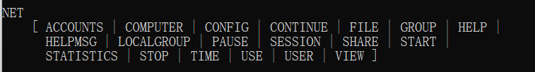

Exercise #9 ipconfig

Type the following command and press Enter

**Type in: ipconfig /?**

Read the help pages for the ipconfig command. What is the purpose/output of the ipconfig command?

Display all current TCP/IP network configuration values

**Type in: ipconfig /flushdns /?**

Read the help pages for the ipconfig command. What is the purpose/output of the ipconfig /flushdns command?

Refresh Domain Name System (DNS) settings

**Type in: color /?**

Read the **help** pages for the color command. What is the purpose/output of the color command

Change font color and background color